Computer Drivers: Translators of the Impossible
(and how they keep us from total anarchy)
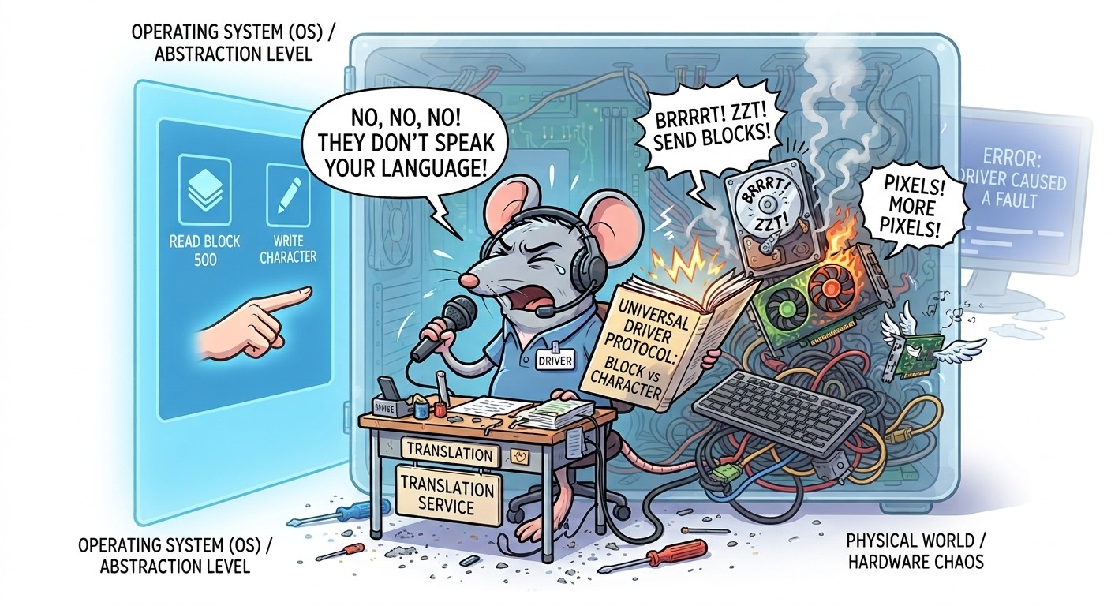
A computer driver (or device driver) is an essential program that acts as the chief translator between the operating system (OS) and the hardware. To put it simply, your operating system is an intellectual living in an abstract ivory tower, while your graphics card or printer are highly specialized workers speaking an incomprehensible electrical jargon. Without the driver to perform the translation, your PC would be nothing more than an expensive, completely mute pile of metal.
From the operating system's perspective, the outside world is actually reduced to its simplest expression: the OS sees the outside world solely as two types of data streams (blocks and characters). The driver therefore has the heavy task of taking the physical reality of a hyper-complex component and forcing it into one of these two universal molds.
Historical Evolution: From the Wild West of MS-DOS to the Golden Cage of Windows 11
The way drivers manage the plumbing and access vital resources—like RAM memory—has fortunately changed significantly. We've come a long way:
- Under MS-DOS (1980s–1990s): It was the Wild West. The system was rudimentary, single-tasking, and had no concept of private property. Applications and drivers (the famous .SYS files that crashed at the slightest misstep) cheerfully bypassed the OS to interact directly with the hardware and write anywhere in RAM. One pixel too far to the left, and the entire system collapsed into complete digital silence.
- The Turning Point of Windows NT and Windows XP: Microsoft finally established law and order with a strict separation of privileges. Absolutely no touching the hardware directly! Drivers were integrated into the system kernel (kernel space). It was more stable, but at the slightest driver bug (often the graphics card driver), disaster struck: the entire system sank along with the driver, giving birth to the collective trauma of the Blue Screen of Death (BSOD).
- Today under Windows 11: We live in a highly secure (and slightly overprotective) republic. Modern drivers (called DCH or Windows Drivers) undergo an entrance exam worthy of the CIA. They often run safely outside the system's sensitive core (in user space) via the Windows Driver Framework (WDF). If they crash, the screen flickers for a second and quietly restarts the driver, without you having to shed a single tear. Plus, Windows Update takes care of updating them automatically behind your back.
The Linux Approach: “Everything is a File” (Even Your Memory!)
While Windows builds cathedrals of frameworks and registries, Linux strictly applies a radical philosophy inherited from Unix: Everything is a file. For the Linux kernel, a USB flash drive, a keyboard, or RAM memory are not physical objects: they are simply text files hidden in the virtual directory /dev/ or /proc/. Linux organizes all of this into two strictly separate categories:
- Character files (sequential access): They represent continuous byte-by-byte streams (like your mouse or keyboard keys). Historically, it was also in this character stream form that Linux allowed users to directly access RAM via the /dev/mem file. Today, for obvious security reasons—such as preventing a malicious script from reading your passwords or rewriting kernel rules on the fly—this direct access to RAM is drastically locked down or eliminated. To check if your RAM is doing fine, you must politely read the /proc/meminfo text file.
- Block files (random access): They represent storage spaces structured into fixed-size chunks (hard drives, SSDs). Thanks to them, the system can cheat and jump straight to the middle of the file without reading everything from the beginning.
The Two Main Types of Drivers: The Poet and the Mover
Since the operating system refuses to see anything other than these two stream categories, drivers are divided into two guilds:
- “Character” drivers: This is the sequential stream. They work teaspoon by teaspoon, transmitting data byte by byte in real time. They don't bother with large buffers: when information arrives, it is transmitted. (Examples: mice, keyboards, serial ports).
- “Block” drivers: These are the movers. They hate tiny details and only move data in fixed-size pallets (512 bytes or 4 KB). They rely heavily on cache memory (buffer memory) to store data while waiting to assemble a complete “block” before writing it all at once to the disk. (Examples: hard drives, SSDs, USB drives).
Core Functions: A Typical Day in the Life of a Driver
To maintain this perfect illusion of very simple files or streams for the operating system, the driver works hard in the background, tackling chore after chore:
- Recognition and Initialization: As soon as you plug in a device, the driver runs after it, identifies it, grants it its ID documents, and configures it so that it can start spitting out its data stream.
- Data Sending and Receiving: It acts as a shuttle. It converts polite OS requests (“Could you please give me data block #500?”) into military orders for the physical chip (“Send current to pin 4!”).
- Interrupt Handling: This is the emergency button. When a peripheral has urgent data (for instance, you just pressed the “Enter” key), it sends a harsh electrical signal (an interrupt) to the processor. The driver intercepts the call so the processor drops what it is doing and processes your command immediately.
- Status Monitoring and Error Management: It acts as the doctor on call. The driver keeps an eye on the hardware. If the cable comes loose or the printer decides to jam paper, the driver translates that physical disaster into a polite, understandable error message for the OS.
- Resource Release: When you safely eject your USB flash drive (instead of yanking it out like a barbarian), the system closes the virtual file and the driver cleans up memory to prevent the PC from choking on residual code.
The Final Word: No Translator, No Engine
Without a driver, even the most brilliant code is merely a series of abstract thoughts, and the most powerful hardware is nothing more than a thousand-dollar technological paperweight. By reducing the chaotic jungle of hardware and memory into two simple universal streams—character and block—the driver performs computer science's greatest magic trick: making your operating system believe that the entire universe boils down to a simple text file.
These are the unsung heroes, invisible and underrated, that keep your 16-core processor daily from having an existential panic attack when faced with a simple USB flash drive. So, the next time your screen flickers for a fraction of a second instead of treating you to a Blue Screen of Death, send a grateful thought to your graphics driver. It just quietly saved your day and kept you from falling into digital chaos.

